**Pull-Apart Cinnamon Sugar Pumpkin Bread with Buttered Rum Glaze**  
(Adapted from [Willow Bird Baking](http://willowbirdbaking.wordpress.com/2011/09/18/pumpkin-spice-pull-apart-bread-with-butter-rum-glaze/" \t "_blank))  
  
*Ingredients*  
*Bread*2 Tbsp unsalted butter  
1/2 cup milk  
2 1/4 teaspoons (1 envelope) active dry yeast  
3/4 cup pumpkin puree  
1/4 cup white sugar  
1 tsp salt  
2 1/2 cups bread flour  
  
1 cup granulated sugar  
2 tsp ground cinnamon  
1/2 tsp fresh ground nutmeg  
2 Tbsp unsalted butter  
  
***Buttered Rum Glaze***   
2 Tbsp unsalted butter  
1/8 cup brown sugar  
1 1/2 Tbsp milk  
3/4 cup powdered sugar  
1 Tbsp rum \*  
  
  
  
*Directions*  
  
In a saucepan over medium-high heat, brown 2 tablespoons of butter, letting it bubble up and turn a dark golden brown but being careful not to allow it burn (turn black). Once browned, remove the pan from the heat and carefully add the milk, return to stove and heat through.\*\*\*\* Pour the milk and butter into the bowl of standing mixer (fitted with a dough hook) and allow to cool so it is no longer hot but also not cool (about 100-110 degrees F). Once it has reached a warm but not hot temperature add the yeast and 1/4 cup of sugar and allow to proof (this can take up to 8 minutes, the top will look foamy and the liquid cloudy). Then add the pumpkin, salt, and 1 cup of flour. Stir until combined then add the rest of the flour 1/2 cup at a time and knead for 6 minutes, until the dough is smooth and elastic and just slightly sticky. If the dough is too moist, add extra flour 1 tablespoon at a time.  
  
Move dough to a lightly oiled bowl and cover with a clean towel. Allow to rise in a warm place for 60-90 minutes or until doubled in size.  
  
While dough is rising, brown another 2 tablespoons of butter. Add the sugar, cinnamon, and nutmeg and mix well.\*\* Making sure sugar evenly absorbs the butter. Set aside. Next, grease and flour a 9x5 loaf pan and set aside.  
  
When the dough has doubled in size, punch it down and flip out onto a clean floured surface and knead with hands for 1-2 minutes. Roll dough into a 20x12 inch rectangle.\*\*\* Evenly sprinkle the dough with the cinnamon sugar mixture and press into dough with palms of the hand. Cut the rectangle into 6 strips. Lay strips on top of each other and cut each strip into 6 even squares (cut in half then each half into thirds). Stack strips vertically into the loaf pan. Cover the pan with a clean towel and let rise for 30-45 minutes.  
  
In the meantime preheat an oven to 350 degrees. After rising in the pan bake for 30-40 minutes (mine took 37 exactly) or until top is a very deep golden brown.  
  
To prepare the glaze, heat the butter, milk, and brown sugar in a small saucepan. Bring to boil then immediately remove the pan from the heat and stir in the rum and powdered sugar.

*\*The recipe I used called for just a 1/4 tsp of rum but I really wanted to be able to taste the rum, so I upped it to a full tablespoon. It was just right for my taste, adding a nice warmth to the glaze. If you're not into rum you can sub a teaspoon of vanilla extract.*  
*\*\*Of course I didn't properly read this section of the directions... I was supposed to melt the butter and brush the dough with the butter then adding the sugar on top of the butter (instead of mixing it all together and sprinkling) but it worked my way so that's how I am listing it. It's really your call!*  
  
*\*\*\* If dough is difficult to roll out, cover with a towel and allow to relax for a few minutes then try again.*  
  
\*\*\*\* *My milk was room temperature. Adding it cold to the butter can result in clumping. Willow Bird Baking called for removing the butter from the pan, then heating the milk, then adding the butter back to the milk. I was lazy which is why I skipped that step. You can also heat the milk separately in the microwave if you'd like.*

*[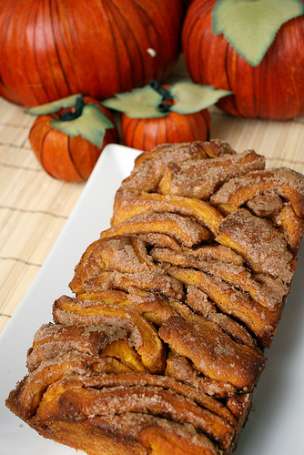](http://farm7.static.flickr.com/6172/6174481478_9174734a06.jpg)*